Karaya 1/48th Ansaldo A.1 Balilla
By
Bill Dedig
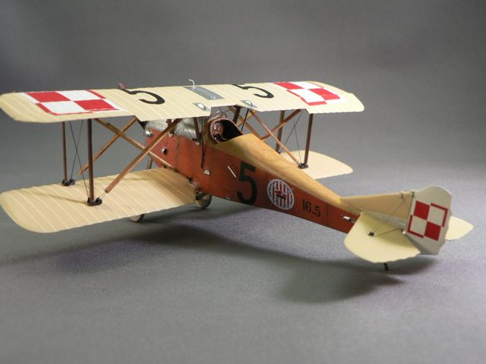

I have built quite a collection of aircraft with the theme “Kościuszko Squadron”. The Ansaldo A.1 Balilla was an Italian designed aircraft used by the Polish aviation squadrons during the Polish-Bolshevik conflict from 1918 to 1921. The 7th Fighter squadron during this conflict was the Kościuszko Squadron and they were formed with the core of American Volunteers. The emblem of this squadron was used from this conflict through WW II and is use today by the Polish Airforce

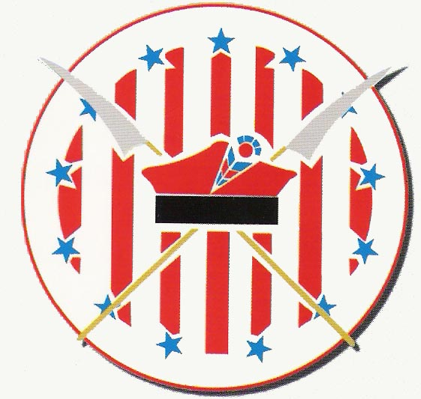

There are quite a few references for this squadron available, however my interest was stirred by the book, “A Question of Honor” by Lynne Olson and Stanley Cloud. This book is focused on the 303Sq of Polish aviators during WWII in Britain. Highly recommended!

Model
The Ansaldo A.1 Balilla was on my holy grail project list since I started the Kościuszko squadron aircraft models. I had not been able to locate a 1/48th kit of this aircraft until Telford World Model Expo in 2012. A chance encounter with a Ansaldo A.1 Balilla at the WWI SIG table and the assistance of the SIG Members including Steve Cox I was led to a Karaya 1/48th Ansaldo A.1 Balilla resin kit.

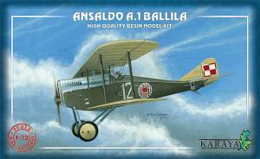

I was a giddy as a school boy. The resin materials and the bi-wing nature of this project were a little concerning.
I would like to thank Tomasz Gronczewski for his article posted in ARC from 2009. This was a great review before beginning this project. His hints and tips saved me a ton of problems.

This kit is really well designed. The details were excellent and the overall fit was very good. My problem areas were warped struts and a difficult landing gear assembly. I replaced the struts and added some brass rod in the ends for support.The instructions were not nearly up to par on the effort used in creating the kit materials. Some very ambiguous interior part locations and rigging details were almost useless. The elevator section and the bracing were very challenging.

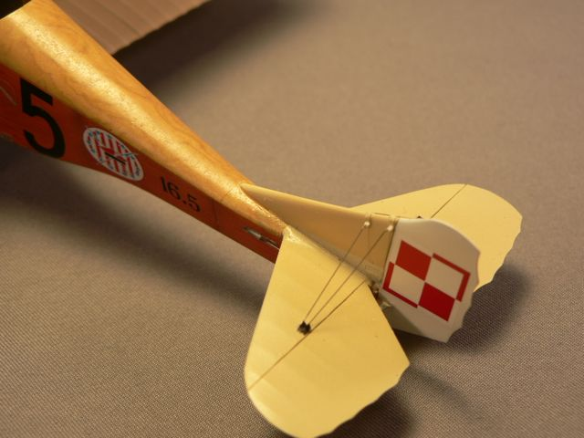

One of the biggest issues was the inter-wing supports. These were not just cables ,but actual wooden structures. This was not easy to duplicate in this scale and I will state that if you scale up my end results you might find them to large.

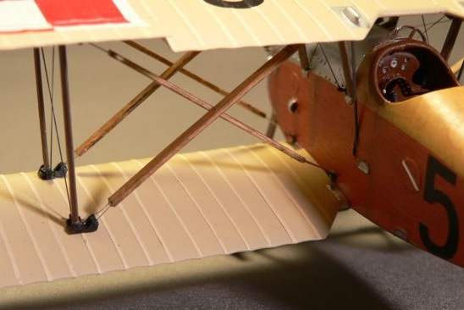
I used wooden toothpicks from a local restaurant chain called “Quaker Steak and Lube”. These items are extremely thin and I flattened them down to create these braces. I like the look.
I used THIN EZ Line for the bracing cables and VERY small steel wire for the bracing wires and strut support connections.

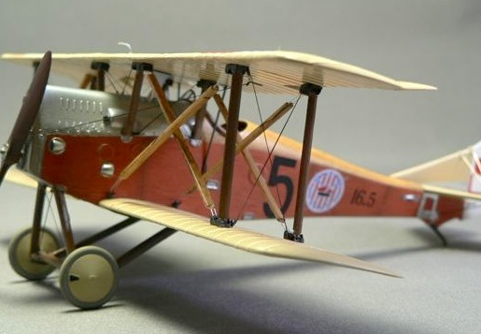
One major issue I had was making a natural wood finished aircraft...way out of my skill range. Along comes some wood grain decals and some base color testing. 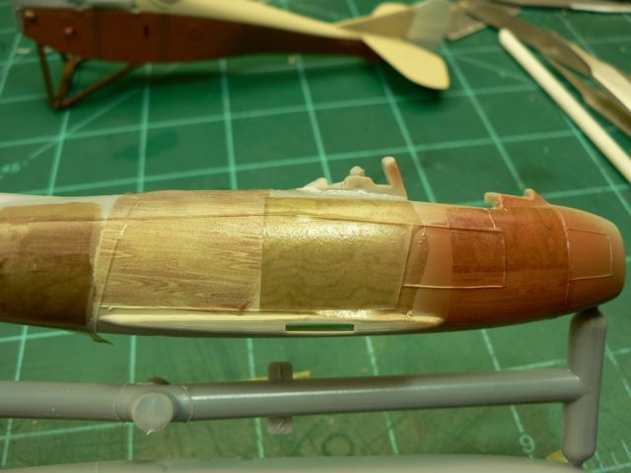
The decals were from two sources, Laser Line and WGSF-48 B that I obtained in Telford this Year. Again another concept that I was very happy with end results.

The markings are kit supplied and are from Techmod. They performed great.
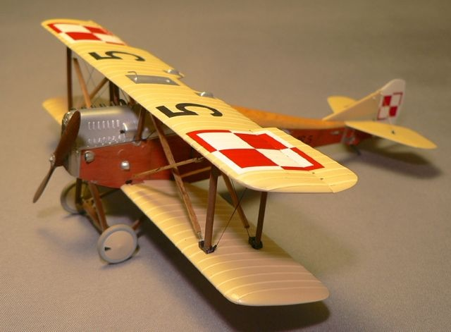
Thats my Ansaldo and I am quite happy with the end result. This one took quite a few hrs over the holidays and I’m hoping for a little easier project for the near future.

