**Airfix SPAD VII**

by Fernando Torre

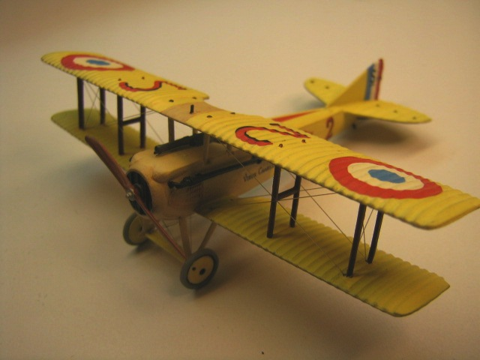

Another old kit for me as usual this one from the 80s..... Airfix Spad Vii.

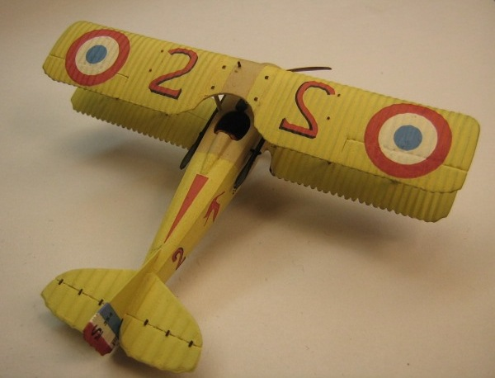

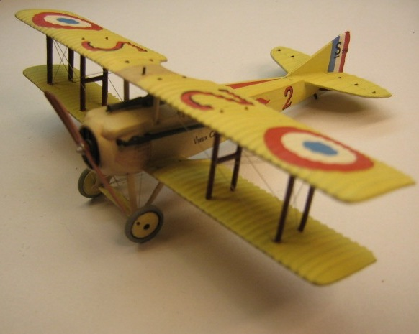

The model depicts aircraft no spad VII S254 ''le vieux Charles''.

This aircraft was used by the ace Georges Guynemer untill 1917,totalizing 18 victories,16 probab le with it 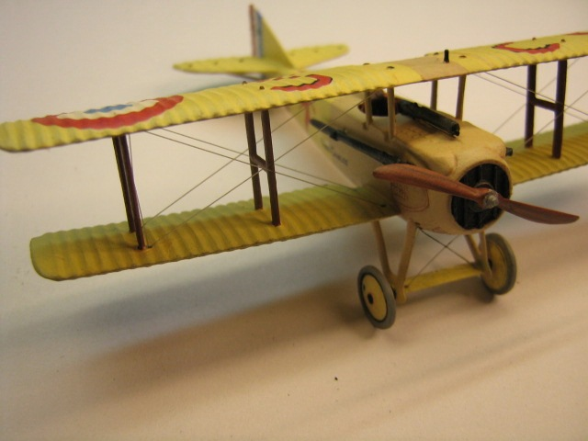

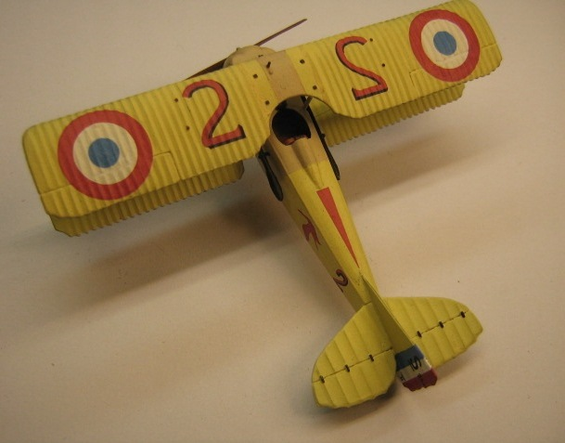

...out of the box...no mods ,just paint glue riging and patience.

Model was painted by brush with Plaid ''Apple Barrel" acrylic art & crafts paint over gray auto primer spray paint .....just call me fancy.!!

stock kit decals were used ....

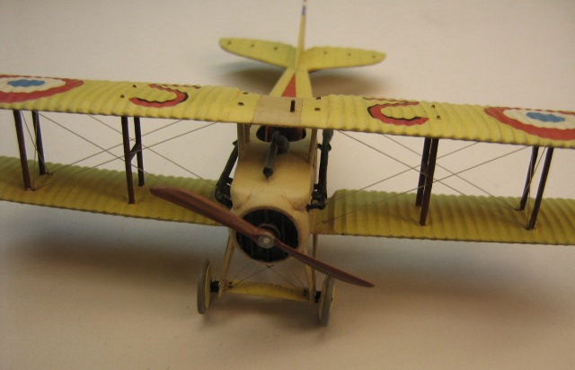

**..... not much to add.. just another weekend build**

**..more or less out of the box and fun to paint ..hope you enjoy it**

**Fern"**

